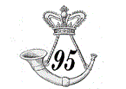
95th Rifles, 1st Battalion
2nd Coy

Military Through the Ages 2019
Date: Mar 3, 2019

A Love Story in the 95th Rifles

Respectfully Submitted by:
James P. Tate III
Sjt, 95th Rifles 1st Battalion, 2nd Coy
7070 Highfields Farm Dr.
Roanoke, VA 24018
(h) 540-989-0298
( C ) 540-798-6044
Jptate3us@aol.com

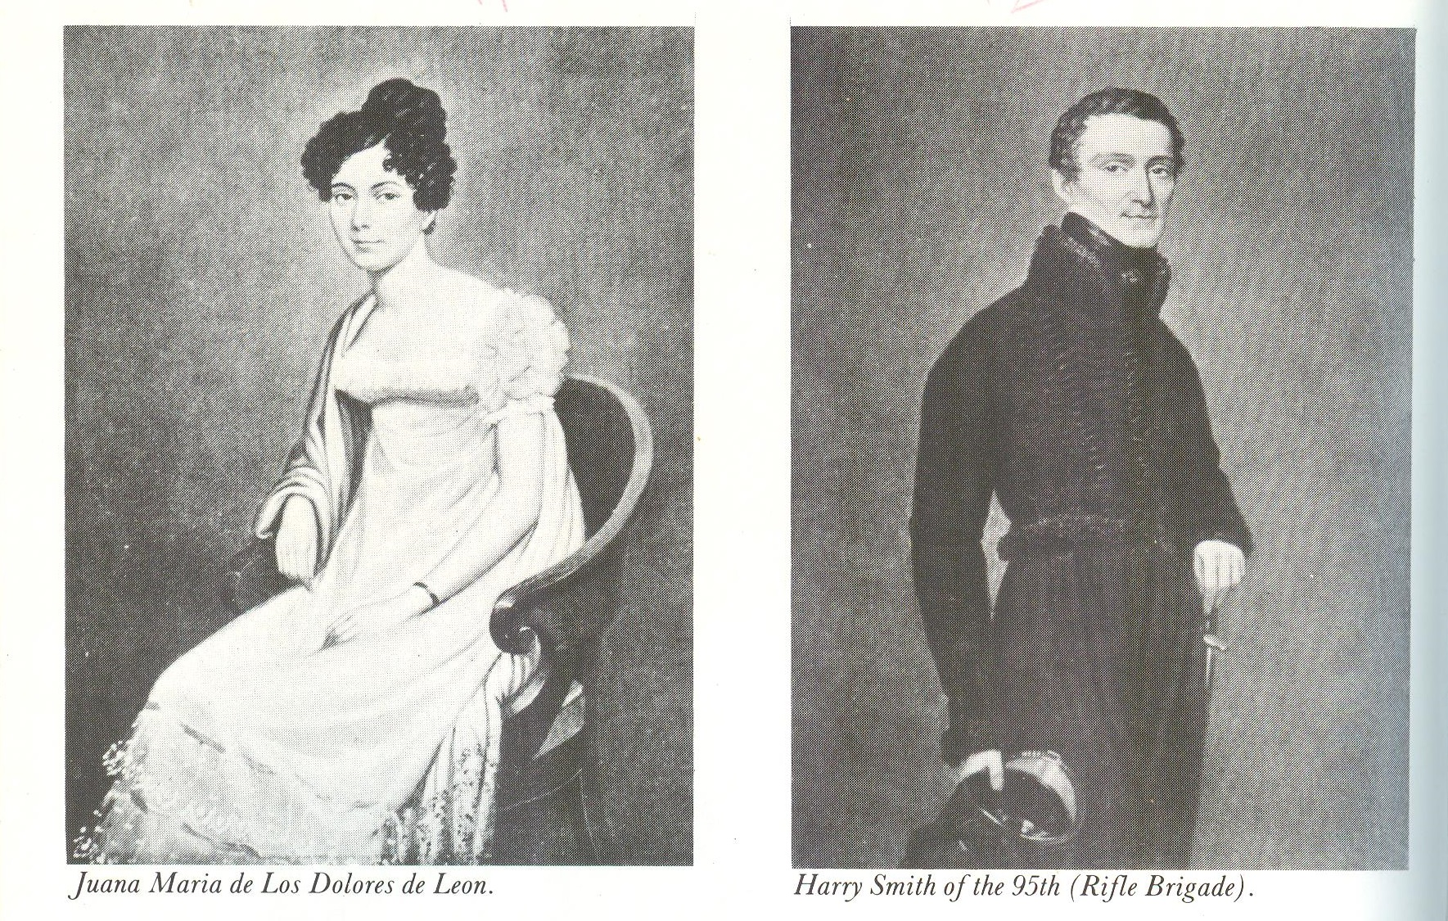

A Love Story in the 95th Rifles

Unlike most British regiments that were sent to the Peninsula in the Napoleonic Wars, the 95th Rifles were not allowed to take their wives or children. Because this elite regiment spent much of its time camping on the forward outpost line of the army, the regimental commander felt that conditions would be too harsh for women. Their presence would be a distraction to the vigilance of the soldiers.
However, many soldiers took Spanish wives during the long war. Of the Spanish wives in the regiment, the most notable was Juana de los Dolores de Leon. After the assault and capture of the city of Badajoz, the British soldiers sacked the city, drinking, looting and committing outrages on the Spanish citizens for a long night before order and discipline could be restored.
During the sacking of the city, a young Spanish noble lady came to the camp of the 95th Rifles pleading for help and safety. This lady brought with her a younger sister. Both ladies had bloody ears where the ransacking British soldiers had ripped out their earrings. (3, p. 343-4). The younger sister captivated the hearts of two Rifles officers, John Kincaid and Harry Smith. But Smith could speak Spanish and had the advantage. This young girl was Juana de los Dolores de Leon. John Kincaid wrote of this meeting, “A being more transcendently lovely I had never before seen … her face was so irresistibly attractive, surmounting a figure cast in nature’s fairest mould, that to look at her was to love her. I did love her, but never told my love, and in the meantime another and more impudent fellow stepped in and won her”. The impudent fellow was Kincaid’s friend, Harry Smith. (3, P. 344)
Juana and Smith fell in love and were married a few weeks later. Wellington, who disapproved of wives in his headquarters, was captivated by her charm, beauty, and grace. He gallantly volunteered to give away the young bride. In deference to her religious convictions, Lord Wellington arranged for the marriage ceremony to be performed by the Roman Catholic chaplain of the 88th Foot (Connaught Rangers of Ireland). Harry Smith was 24 years old and the young bride, Juana, was fourteen years old. The rescue and marriage forever changed Harry Smith’s life. He later wrote of his lady:

Never was one so honoured and distinguished as I have been by the possession of this dear child (for she was little more than a child at this moment), one with a sense of honour no knight ever exceeded in the most romantic days of chivalry, an understanding superior to her years. A masculine mind with a force of character no consideration could turn from her own just sense of rectitude, and all encased in a frame of Nature’s fairest and most delicate moulding, the figure of an angel, with an eye of light and an expression which then inspired me with a maddening love. (1, p. 178)

Smith was known throughout the army as brave, energetic and rising young officer. His friends were stunned to think that Smith would jeopardize his promising career with such an early marriage. There was the question of religion: Harry was a devout Protestant and Juana was a Roman Catholic. The marriage would be subject to the hardships of army campaigning? How would this delicate young girl bear up under camp life. Harry dismissed these arguments. To Harry’s thinking he would be a better officer because he would be inspired by her love.
Juana Maria de Los Dolores de Leon was from one of Spain’s oldest families and was a descendent of Ponce de Leon. She was a determined young girl and chose to accompany her husband through the remainder of the Peninsula War. She shared his army quarters, and hardships without complaint. This quiet, beautiful, thoughtful young lady was highly regarded by the officers and men of the Rifles. Juana was portrayed as “Guided by a just sense of rectitude, an innate purity of mind, a singleness of purpose which defied malice, and a soul that soared above circumstances, she became alike the adored of the camp and the drawing room, and eventually the admired associate of princes.” (3, p. 345). Harry wrote of Juana’s friendship with the soldiers, “she would laugh and talk with all, which a soldier likes”. (2, p.31).
Thus, began one of the most romantic love stories of the first half of the 19th century. This love story of Harry and Juana Smith is the inspiration for Georgette Heyers’ historical novel, “The Spanish Bride”.
At one time, Juana was thrown by her Portuguese horse and refused to ride him. She demanded to ride a spirited Spanish horse and quickly brought him under control. As Harry wrote of this incident, “ It is difficult to say who was the proudest that morning … horse, wife or Enrique( as Juana referred to Harry), as she caracoled him about among the soldiers to their delight.” (2, p. 30)
On another occasion, the colonel of the 95th Rifles gave Harry and Juana a hut made largely of mud as living quarters. Juana had a warm meal prepared for Harry’s arrival. After they retired to a nuptial bed, a violent rain storm came up and the hut roof collapsed on them and covered them with wet mud. Harry recounted that Juana “laughed herself warm”. (2, p. 47)

During the lulls in the fighting, Harry and Juana were the favorites of the social gatherings because they both spoke Spanish and could converse with the local gentry. John Kincaid recalled a masked ball at which Juana thought Harry was flirting with a Spanish lady. Juana marched over and boxed Harry’s ears. He responded by called her a “fiery little varmint”. A terrible argument ensued, “but like all their rows ended up with tears, kisses and passionate embraces”. (2, p. 41)
Juana and Harry were separated during Harry’s posting to the British army in America. Smith was a Deputy Adjutant General to the commanding officer of the army that burned Washington. During this campaign Juana was sent to stay in London. She was overwhelmed by the bustle and traffic of the large English city. However, her stay in London was brightened by visits from Harry’s army friends and his brother, Tom, a fellow Rifles officer. These visitors did their best to lift her spirits. At first, Juana was too embarrassed to visit Harry’s family because of her poor command of English. Recognizing her lack of English as a handicap, she engaged a tutor to coach her in vocabulary and pronunciation. The tutor endeavored to curtail her use of the more “fruity phases” she had picked up from the Riflemen on campaign. (2, p. 56)
Harry returned from the Washington campaign carrying dispatches for the Prince Regent and the War Office. This duty gave him time to reunite with Juana. They journeyed to Harry’s home in Whittlesey, Cambridgeshire and Juana was introduced to Harry’s family. The sparkling young wife immediately captivated everyone in the family. Her husband’s brothers and sisters-in-law delighted in teasing her about her English pronunciation. But, when she had too much of the teasing, and exploded in a torrent of Spanish, the conversation was transformed to laughter; much to the delight of her proud husband. (2, p.65).
Harry was called to the brigade staff of General Lambert in the mobilization to challenge Napoleon’s return to France in May 1815. This time, Juana accompanied Harry with the army. He ordered her to return to Brussels as the British and Allied armies met the French at Mont St. Jean near Waterloo. Harry’s part in the monumental battle garnered him more accolades and praise.
After the battle, Juana learned that Brigade Major Smith had been killed in the battle. Distraught, Juana, accompanied only by Harry’s groom, West, rushed to the battlefield. She was desperate with grief and sought to claim his body and prevent him from being buried on an unmarked grave. As she searched the battlefield, she prayed to God to find Harry’s body. In her search she met Charlie Gore, a close friend from the Peninsula days. Asked to find Harry’s body, Gore told her he was alive and well at Brigade HQ. He confirmed that the Brigade Major Smith reported as dead was another man of the same name. Her Harry and his brothers had come through the battle safely. (2, p. 85-86)
At the conclusion of the Napoleonic Wars, Harry Smith remained in the army and was assigned to many far-flung stations in the growing British Empire. Juana always accompanied her husband in the remote stations and was a charming hostess.
For a time in the 1840s Harry was the senior staff officer for the commanding general of the British Army stationed in India. In an uprising of the Maharatta princes in 1843, Harry Smith was given command of a division of troops. At the Battle of Maharajpore, Harry’s division resoundingly defeated a large Maharatta army. During the battle, a number of wives of the British officers decided to watch the battle from the top of elephants. This troop of elephants came under fire during one stage of the battle. It was the quick, decisive action of Juana that brought all the wives to safety. For her courageous action, Juana Smith was awarded a special medal by Queen Victoria. (2, p. 120-1).
In honor of his long and distinguished military service, Harry was granted a baronetcy and raised to Knight Grand Cross of the Order of the Bath (GCB). Thus, he became Sir Harry Smith and Juana became Lady Smith.
After service in India, Harry Smith was promoted to the rank of major general and was appointed the governor of the Cape Colony in South Africa. He established himself as an able administrator and political leader. A little town in Natal province decided to change its name to Smith to honor the governor. Harry Smith demurred because he considered it unsuitable for a town to be named for a military leader. The townspeople then decided to name their town after Juana Smith. The city of Ladysmith in Natal province is a key city in the Republic of South Africa.
Harry and Juana remained devoted to each other all their lives. “They both had their tempers and tantrums, but like many that do, quickly made up and fell into each other’s arms.” (2, p. 184). Juana endeared herself to the hard-bitten Peninsula soldiery amongst whom she slept, wrapped in a blanket by her horse, … “. (2, p.184). For her service and devotion to her husband and the Empire, Lady Juana Smith was granted a pension by the British government.
In retirement, Harry Smith died in 1860 and Juana Smith died in 1872. They are buried together in the churchyard of Whittlesey, Cambridgeshire where Harry was born. (2, p. xi)

Bibliography;
- Rifles, Six Years With Wellington’s Legendary Sharpshooters; Mark Urban, Faber and Faber Limited, 3 Queen Square London WC1N 3AU, 2003
- In Love and War; David Rooney and Michael Scott; Pen & Sword Books Ltd.; 47 Church St., Barneley South Yorkshire S70 2AS, 2008
- The Complete Kincaid of the Rifles; by John Kincaid; Leonaur; copyright 2011 from Oakpast, Ltd. http://www.leonaur.com

